1 run......

Downloading: 100%

445M/445M [00:19<00:00, 23.3MB/s]

training 1 epoch...

44.78337907791138 seconds used......

1 training finished! average train loss: 0.6105061263864876

evaluating...

Confusion matrix, without normalization

[[ 10 67 19]

[ 1 275 79]

[ 1 62 656]]

Normalized confusion matrix

[[0.10416667 0.69791667 0.19791667]

[0.0028169 0.77464789 0.22253521]

[0.00139082 0.08623088 0.9123783 ]]

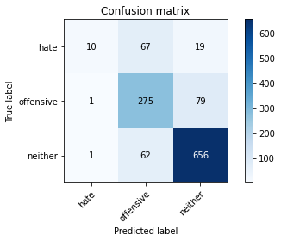

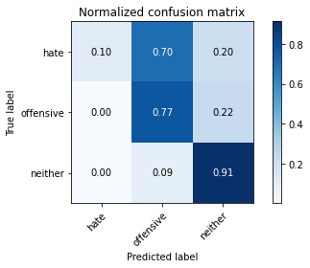

precision recall f1-score support

hate 0.83 0.10 0.19 96

offensive 0.68 0.77 0.72 355

neither 0.87 0.91 0.89 719

accuracy 0.80 1170

macro avg 0.79 0.60 0.60 1170

weighted avg 0.81 0.80 0.78 1170

average eval_loss: 0.48867755181203454, accuracy: 0.8042735042735043

training 2 epoch...

44.07258176803589 seconds used......

2 training finished! average train loss: 0.34013136914079517

evaluating...

Confusion matrix, without normalization

[[ 11 55 30]

[ 3 235 117]

[ 1 16 702]]

Normalized confusion matrix

[[0.11458333 0.57291667 0.3125 ]

[0.0084507 0.66197183 0.32957746]

[0.00139082 0.02225313 0.97635605]]

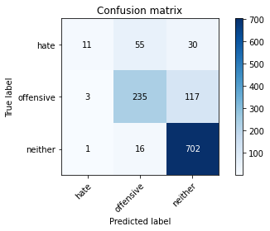

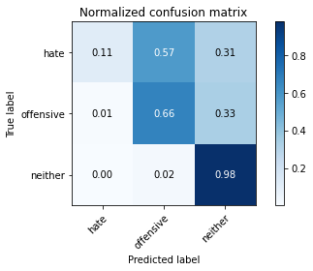

precision recall f1-score support

hate 0.73 0.11 0.20 96

offensive 0.77 0.66 0.71 355

neither 0.83 0.98 0.90 719

accuracy 0.81 1170

macro avg 0.78 0.58 0.60 1170

weighted avg 0.80 0.81 0.78 1170

average eval_loss: 0.5191457369128021, accuracy: 0.8102564102564103

training 3 epoch...

44.04727649688721 seconds used......

3 training finished! average train loss: 0.15819405414299387

evaluating...

Confusion matrix, without normalization

[[ 57 24 15]

[ 19 276 60]

[ 16 56 647]]

Normalized confusion matrix

[[0.59375 0.25 0.15625 ]

[0.05352113 0.77746479 0.16901408]

[0.02225313 0.07788595 0.89986092]]

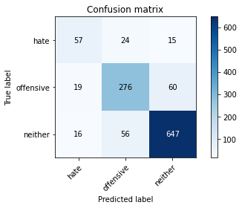

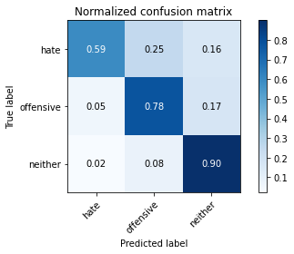

precision recall f1-score support

hate 0.62 0.59 0.61 96

offensive 0.78 0.78 0.78 355

neither 0.90 0.90 0.90 719

accuracy 0.84 1170

macro avg 0.76 0.76 0.76 1170

weighted avg 0.84 0.84 0.84 1170

average eval_loss: 0.5020549745314707, accuracy: 0.8376068376068376

training 4 epoch...

43.96381998062134 seconds used......

4 training finished! average train loss: 0.07628717875947905

evaluating...

Confusion matrix, without normalization

[[ 51 29 16]

[ 15 278 62]

[ 17 72 630]]

Normalized confusion matrix

[[0.53125 0.30208333 0.16666667]

[0.04225352 0.78309859 0.17464789]

[0.02364395 0.10013908 0.87621697]]

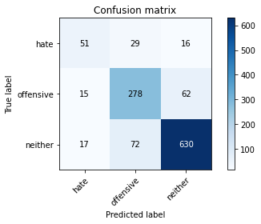

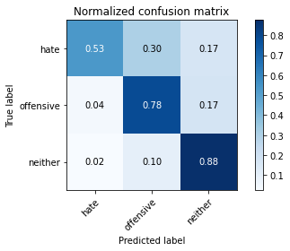

precision recall f1-score support

hate 0.61 0.53 0.57 96

offensive 0.73 0.78 0.76 355

neither 0.89 0.88 0.88 719

accuracy 0.82 1170

macro avg 0.75 0.73 0.74 1170

weighted avg 0.82 0.82 0.82 1170

average eval_loss: 0.6733229217766705, accuracy: 0.8196581196581196

training 5 epoch...

44.045329332351685 seconds used......

5 training finished! average train loss: 0.05175231375759388

evaluating...

Confusion matrix, without normalization

[[ 36 40 20]

[ 8 263 84]

[ 4 52 663]]

Normalized confusion matrix

[[0.375 0.41666667 0.20833333]

[0.02253521 0.74084507 0.23661972]

[0.00556328 0.07232267 0.92211405]]

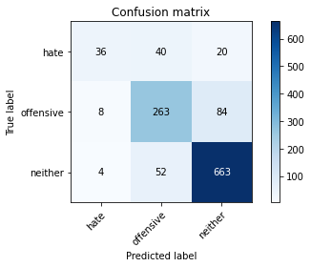

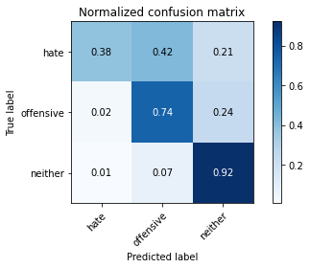

precision recall f1-score support

hate 0.75 0.38 0.50 96

offensive 0.74 0.74 0.74 355

neither 0.86 0.92 0.89 719

accuracy 0.82 1170

macro avg 0.79 0.68 0.71 1170

weighted avg 0.82 0.82 0.81 1170

average eval_loss: 0.7150081404232247, accuracy: 0.8222222222222222

training 6 epoch...

43.97254514694214 seconds used......

6 training finished! average train loss: 0.028829584488223314

evaluating...

Confusion matrix, without normalization

[[ 42 37 17]

[ 8 255 92]

[ 7 45 667]]

Normalized confusion matrix

[[0.4375 0.38541667 0.17708333]

[0.02253521 0.71830986 0.25915493]

[0.00973574 0.06258693 0.92767733]]

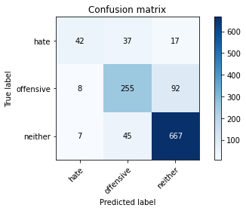

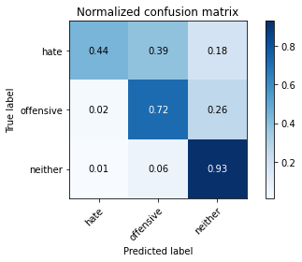

precision recall f1-score support

hate 0.74 0.44 0.55 96

offensive 0.76 0.72 0.74 355

neither 0.86 0.93 0.89 719

accuracy 0.82 1170

macro avg 0.78 0.69 0.73 1170

weighted avg 0.82 0.82 0.82 1170

average eval_loss: 0.8706114602480399, accuracy: 0.8239316239316239

training 7 epoch...

44.09222078323364 seconds used......

7 training finished! average train loss: 0.032040522011065595

evaluating...

Confusion matrix, without normalization

[[ 39 43 14]

[ 12 274 69]

[ 15 60 644]]

Normalized confusion matrix

[[0.40625 0.44791667 0.14583333]

[0.03380282 0.77183099 0.1943662 ]

[0.02086231 0.08344924 0.89568846]]

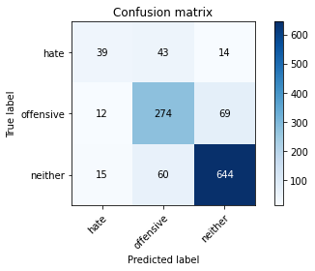

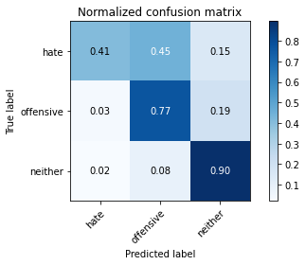

precision recall f1-score support

hate 0.59 0.41 0.48 96

offensive 0.73 0.77 0.75 355

neither 0.89 0.90 0.89 719

accuracy 0.82 1170

macro avg 0.73 0.69 0.71 1170

weighted avg 0.81 0.82 0.81 1170

average eval_loss: 0.7670470022643774, accuracy: 0.8179487179487179

training 8 epoch...

43.95735263824463 seconds used......

8 training finished! average train loss: 0.02086055853218039

evaluating...

Confusion matrix, without normalization

[[ 49 35 12]

[ 11 268 76]

[ 15 68 636]]

Normalized confusion matrix

[[0.51041667 0.36458333 0.125 ]

[0.03098592 0.75492958 0.21408451]

[0.02086231 0.0945758 0.88456189]]

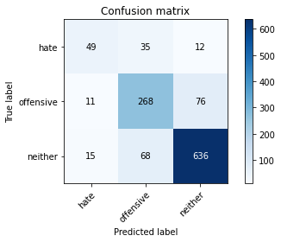

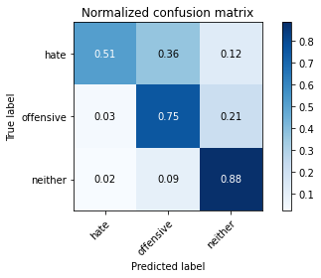

precision recall f1-score support

hate 0.65 0.51 0.57 96

offensive 0.72 0.75 0.74 355

neither 0.88 0.88 0.88 719

accuracy 0.81 1170

macro avg 0.75 0.72 0.73 1170

weighted avg 0.81 0.81 0.81 1170

average eval_loss: 0.864064826310407, accuracy: 0.8145299145299145

training 9 epoch...

44.150981426239014 seconds used......

9 training finished! average train loss: 0.021849560801526353

evaluating...

Confusion matrix, without normalization

[[ 54 19 23]

[ 23 244 88]

[ 14 39 666]]

Normalized confusion matrix

[[0.5625 0.19791667 0.23958333]

[0.06478873 0.68732394 0.24788732]

[0.01947149 0.054242 0.92628651]]

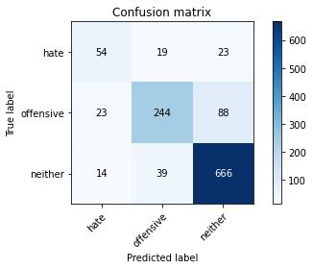

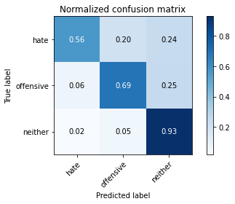

precision recall f1-score support

hate 0.59 0.56 0.58 96

offensive 0.81 0.69 0.74 355

neither 0.86 0.93 0.89 719

accuracy 0.82 1170

macro avg 0.75 0.73 0.74 1170

weighted avg 0.82 0.82 0.82 1170

average eval_loss: 0.8811459781831896, accuracy: 0.8239316239316239

training 10 epoch...

44.088226556777954 seconds used......

10 training finished! average train loss: 0.02296012997074783

evaluating...

Confusion matrix, without normalization

[[ 47 38 11]

[ 13 300 42]

[ 10 126 583]]

Normalized confusion matrix

[[0.48958333 0.39583333 0.11458333]

[0.03661972 0.84507042 0.11830986]

[0.01390821 0.17524339 0.8108484 ]]

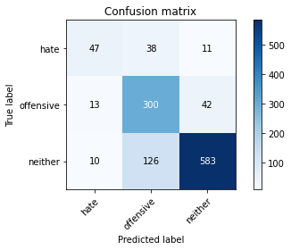

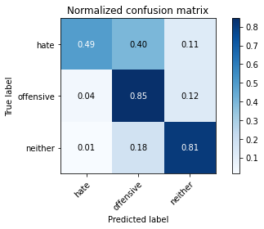

precision recall f1-score support

hate 0.67 0.49 0.57 96

offensive 0.65 0.85 0.73 355

neither 0.92 0.81 0.86 719

accuracy 0.79 1170

macro avg 0.74 0.72 0.72 1170

weighted avg 0.81 0.79 0.80 1170

average eval_loss: 0.9043981871109897, accuracy: 0.7948717948717948

2 run......

training 1 epoch...

44.16070342063904 seconds used......

1 training finished! average train loss: 0.6250699911998887

evaluating...

Confusion matrix, without normalization

[[ 12 58 26]

[ 3 278 74]

[ 0 64 655]]

Normalized confusion matrix

[[0.125 0.60416667 0.27083333]

[0.0084507 0.78309859 0.2084507 ]

[0. 0.08901252 0.91098748]]

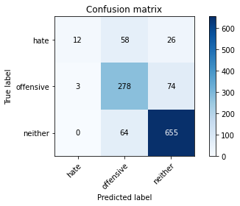

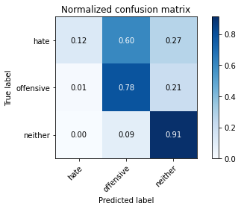

precision recall f1-score support

hate 0.80 0.12 0.22 96

offensive 0.69 0.78 0.74 355

neither 0.87 0.91 0.89 719

accuracy 0.81 1170

macro avg 0.79 0.61 0.61 1170

weighted avg 0.81 0.81 0.79 1170

average eval_loss: 0.4523455586473821, accuracy: 0.8076923076923077

training 2 epoch...

43.973639726638794 seconds used......

2 training finished! average train loss: 0.33859150955437595

evaluating...

Confusion matrix, without normalization

[[ 67 7 22]

[ 68 192 95]

[ 19 24 676]]

Normalized confusion matrix

[[0.69791667 0.07291667 0.22916667]

[0.1915493 0.54084507 0.26760563]

[0.02642559 0.03337969 0.94019471]]

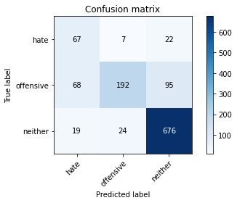

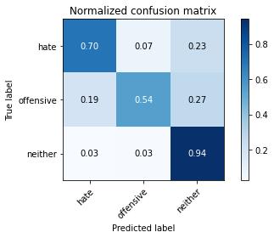

precision recall f1-score support

hate 0.44 0.70 0.54 96

offensive 0.86 0.54 0.66 355

neither 0.85 0.94 0.89 719

accuracy 0.80 1170

macro avg 0.72 0.73 0.70 1170

weighted avg 0.82 0.80 0.80 1170

average eval_loss: 0.5139987072197058, accuracy: 0.7991452991452992

training 3 epoch...

43.84722924232483 seconds used......

3 training finished! average train loss: 0.14528711839443725

evaluating...

Confusion matrix, without normalization

[[ 44 36 16]

[ 12 295 48]

[ 15 91 613]]

Normalized confusion matrix

[[0.45833333 0.375 0.16666667]

[0.03380282 0.83098592 0.13521127]

[0.02086231 0.12656467 0.85257302]]

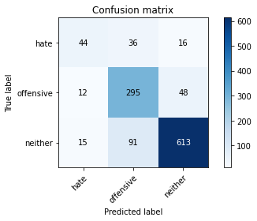

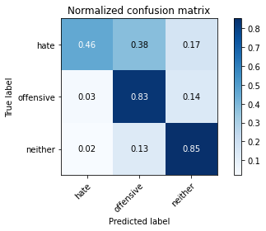

precision recall f1-score support

hate 0.62 0.46 0.53 96

offensive 0.70 0.83 0.76 355

neither 0.91 0.85 0.88 719

accuracy 0.81 1170

macro avg 0.74 0.71 0.72 1170

weighted avg 0.82 0.81 0.81 1170

average eval_loss: 0.5867356534226466, accuracy: 0.8136752136752137

training 4 epoch...

44.02154493331909 seconds used......

4 training finished! average train loss: 0.0735785230431053

evaluating...

Confusion matrix, without normalization

[[ 62 23 11]

[ 32 270 53]

[ 24 88 607]]

Normalized confusion matrix

[[0.64583333 0.23958333 0.11458333]

[0.09014085 0.76056338 0.14929577]

[0.03337969 0.12239221 0.84422809]]

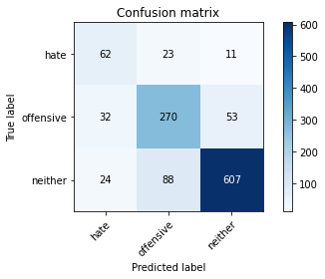

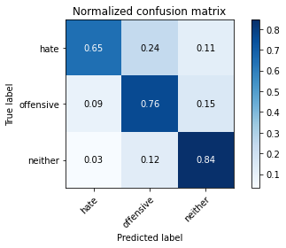

precision recall f1-score support

hate 0.53 0.65 0.58 96

offensive 0.71 0.76 0.73 355

neither 0.90 0.84 0.87 719

accuracy 0.80 1170

macro avg 0.71 0.75 0.73 1170

weighted avg 0.81 0.80 0.81 1170

average eval_loss: 0.6190387322488478, accuracy: 0.8025641025641026

training 5 epoch...

43.84203743934631 seconds used......

5 training finished! average train loss: 0.044943735277843386

evaluating...

Confusion matrix, without normalization

[[ 33 41 22]

[ 5 281 69]

[ 5 59 655]]

Normalized confusion matrix

[[0.34375 0.42708333 0.22916667]

[0.01408451 0.7915493 0.1943662 ]

[0.0069541 0.08205841 0.91098748]]

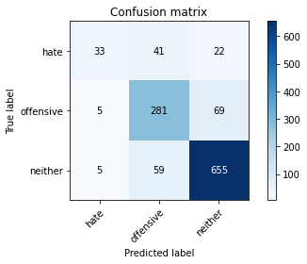

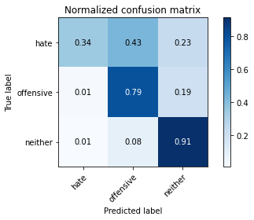

precision recall f1-score support

hate 0.77 0.34 0.47 96

offensive 0.74 0.79 0.76 355

neither 0.88 0.91 0.89 719

accuracy 0.83 1170

macro avg 0.79 0.68 0.71 1170

weighted avg 0.83 0.83 0.82 1170

average eval_loss: 0.7818831922604813, accuracy: 0.8282051282051283

training 6 epoch...

43.998313188552856 seconds used......

6 training finished! average train loss: 0.03714791355972003

evaluating...

Confusion matrix, without normalization

[[ 57 23 16]

[ 29 258 68]

[ 16 58 645]]

Normalized confusion matrix

[[0.59375 0.23958333 0.16666667]

[0.08169014 0.72676056 0.1915493 ]

[0.02225313 0.08066759 0.89707928]]

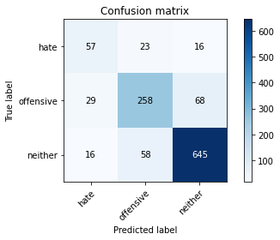

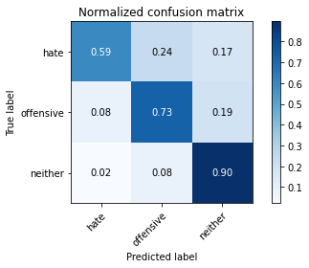

precision recall f1-score support

hate 0.56 0.59 0.58 96

offensive 0.76 0.73 0.74 355

neither 0.88 0.90 0.89 719

accuracy 0.82 1170

macro avg 0.73 0.74 0.74 1170

weighted avg 0.82 0.82 0.82 1170

average eval_loss: 0.7494861342139163, accuracy: 0.8205128205128205

training 7 epoch...

43.82835268974304 seconds used......

7 training finished! average train loss: 0.018772196999448054

evaluating...

Confusion matrix, without normalization

[[ 47 25 24]

[ 13 236 106]

[ 4 33 682]]

Normalized confusion matrix

[[0.48958333 0.26041667 0.25 ]

[0.03661972 0.66478873 0.29859155]

[0.00556328 0.04589708 0.94853964]]

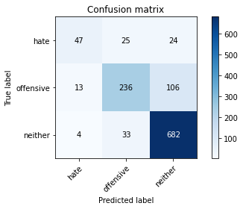

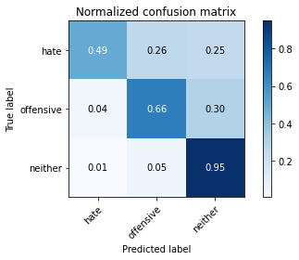

precision recall f1-score support

hate 0.73 0.49 0.59 96

offensive 0.80 0.66 0.73 355

neither 0.84 0.95 0.89 719

accuracy 0.82 1170

macro avg 0.79 0.70 0.74 1170

weighted avg 0.82 0.82 0.82 1170

average eval_loss: 0.99191911242482, accuracy: 0.8247863247863247

training 8 epoch...

44.06950783729553 seconds used......

8 training finished! average train loss: 0.023133234456532266

evaluating...

Confusion matrix, without normalization

[[ 57 24 15]

[ 28 253 74]

[ 13 58 648]]

Normalized confusion matrix

[[0.59375 0.25 0.15625 ]

[0.07887324 0.71267606 0.2084507 ]

[0.01808067 0.08066759 0.90125174]]

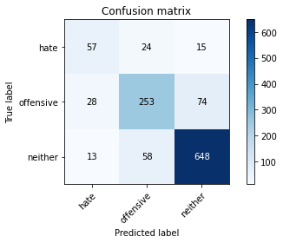

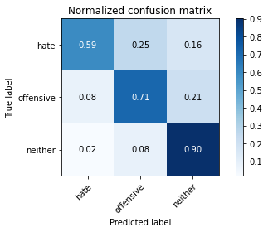

precision recall f1-score support

hate 0.58 0.59 0.59 96

offensive 0.76 0.71 0.73 355

neither 0.88 0.90 0.89 719

accuracy 0.82 1170

macro avg 0.74 0.74 0.74 1170

weighted avg 0.82 0.82 0.82 1170

average eval_loss: 0.710831306495909, accuracy: 0.8188034188034188

training 9 epoch...

43.80263304710388 seconds used......

9 training finished! average train loss: 0.034854844065520384

evaluating...

Confusion matrix, without normalization

[[ 40 44 12]

[ 9 300 46]

[ 12 112 595]]

Normalized confusion matrix

[[0.41666667 0.45833333 0.125 ]

[0.02535211 0.84507042 0.12957746]

[0.01668985 0.15577191 0.82753825]]

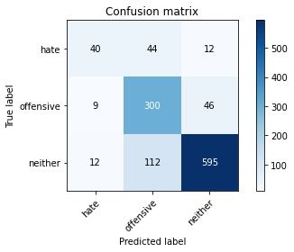

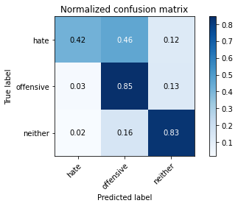

precision recall f1-score support

hate 0.66 0.42 0.51 96

offensive 0.66 0.85 0.74 355

neither 0.91 0.83 0.87 719

accuracy 0.80 1170

macro avg 0.74 0.70 0.71 1170

weighted avg 0.81 0.80 0.80 1170

average eval_loss: 0.8385204747003518, accuracy: 0.7991452991452992

training 10 epoch...

43.91359329223633 seconds used......

10 training finished! average train loss: 0.0215213846262424

evaluating...

Confusion matrix, without normalization

[[ 49 30 17]

[ 18 265 72]

[ 13 59 647]]

Normalized confusion matrix

[[0.51041667 0.3125 0.17708333]

[0.05070423 0.74647887 0.2028169 ]

[0.01808067 0.08205841 0.89986092]]

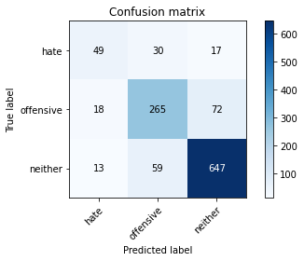

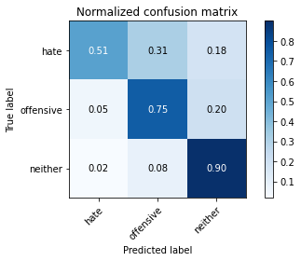

precision recall f1-score support

hate 0.61 0.51 0.56 96

offensive 0.75 0.75 0.75 355

neither 0.88 0.90 0.89 719

accuracy 0.82 1170

macro avg 0.75 0.72 0.73 1170

weighted avg 0.82 0.82 0.82 1170

average eval_loss: 0.8791184050832102, accuracy: 0.8213675213675213

3 run......

training 1 epoch...

43.95156764984131 seconds used......

1 training finished! average train loss: 0.6122755341422863

evaluating...

Confusion matrix, without normalization

[[ 20 60 16]

[ 3 279 73]

[ 9 77 633]]

Normalized confusion matrix

[[0.20833333 0.625 0.16666667]

[0.0084507 0.78591549 0.2056338 ]

[0.01251739 0.10709318 0.88038943]]

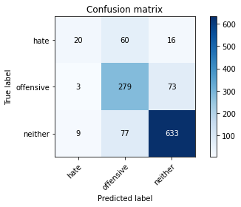

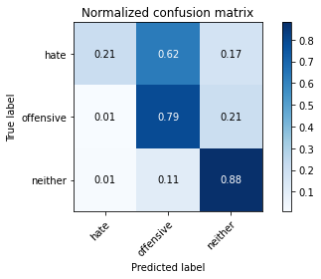

precision recall f1-score support

hate 0.62 0.21 0.31 96

offensive 0.67 0.79 0.72 355

neither 0.88 0.88 0.88 719

accuracy 0.80 1170

macro avg 0.72 0.62 0.64 1170

weighted avg 0.79 0.80 0.79 1170

average eval_loss: 0.48338337293115713, accuracy: 0.7965811965811965

training 2 epoch...

43.92723631858826 seconds used......

2 training finished! average train loss: 0.37405748149523366

evaluating...

Confusion matrix, without normalization

[[ 37 39 20]

[ 5 274 76]

[ 8 48 663]]

Normalized confusion matrix

[[0.38541667 0.40625 0.20833333]

[0.01408451 0.77183099 0.21408451]

[0.01112656 0.06675939 0.92211405]]

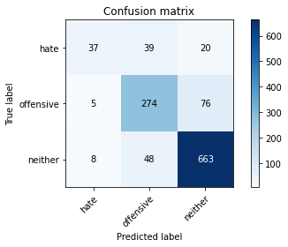

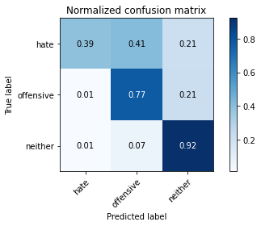

precision recall f1-score support

hate 0.74 0.39 0.51 96

offensive 0.76 0.77 0.77 355

neither 0.87 0.92 0.90 719

accuracy 0.83 1170

macro avg 0.79 0.69 0.72 1170

weighted avg 0.83 0.83 0.83 1170

average eval_loss: 0.42041318863630295, accuracy: 0.8324786324786325

training 3 epoch...

43.96827793121338 seconds used......

3 training finished! average train loss: 0.20076028029155782

evaluating...

Confusion matrix, without normalization

[[ 44 42 10]

[ 19 295 41]

[ 20 104 595]]

Normalized confusion matrix

[[0.45833333 0.4375 0.10416667]

[0.05352113 0.83098592 0.11549296]

[0.02781641 0.14464534 0.82753825]]

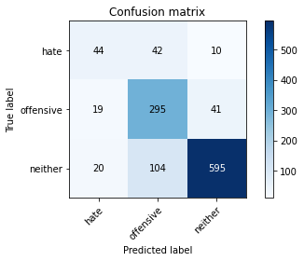

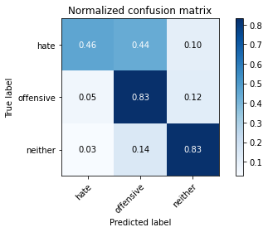

precision recall f1-score support

hate 0.53 0.46 0.49 96

offensive 0.67 0.83 0.74 355

neither 0.92 0.83 0.87 719

accuracy 0.80 1170

macro avg 0.71 0.71 0.70 1170

weighted avg 0.81 0.80 0.80 1170

average eval_loss: 0.5750558575836279, accuracy: 0.7982905982905983

training 4 epoch...

43.92735290527344 seconds used......

4 training finished! average train loss: 0.0909096199967381

evaluating...

Confusion matrix, without normalization

[[ 45 32 19]

[ 16 274 65]

[ 9 57 653]]

Normalized confusion matrix

[[0.46875 0.33333333 0.19791667]

[0.04507042 0.77183099 0.18309859]

[0.01251739 0.07927677 0.90820584]]

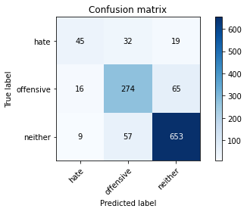

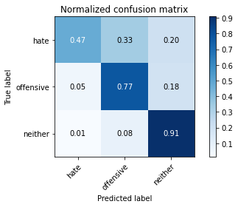

precision recall f1-score support

hate 0.64 0.47 0.54 96

offensive 0.75 0.77 0.76 355

neither 0.89 0.91 0.90 719

accuracy 0.83 1170

macro avg 0.76 0.72 0.73 1170

weighted avg 0.83 0.83 0.83 1170

average eval_loss: 0.6033910993423502, accuracy: 0.8307692307692308

training 5 epoch...

44.203476905822754 seconds used......

5 training finished! average train loss: 0.05897709793778351

evaluating...

Confusion matrix, without normalization

[[ 49 23 24]

[ 17 265 73]

[ 7 54 658]]

Normalized confusion matrix

[[0.51041667 0.23958333 0.25 ]

[0.04788732 0.74647887 0.2056338 ]

[0.00973574 0.07510431 0.91515994]]

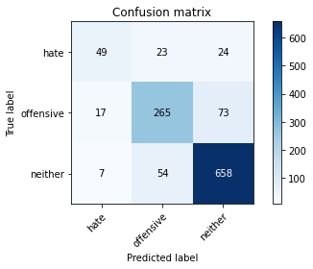

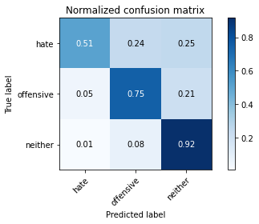

precision recall f1-score support

hate 0.67 0.51 0.58 96

offensive 0.77 0.75 0.76 355

neither 0.87 0.92 0.89 719

accuracy 0.83 1170

macro avg 0.77 0.72 0.74 1170

weighted avg 0.83 0.83 0.83 1170

average eval_loss: 0.6551656066617628, accuracy: 0.8307692307692308

training 6 epoch...

43.8622407913208 seconds used......

6 training finished! average train loss: 0.048491871756059714

evaluating...

Confusion matrix, without normalization

[[ 42 36 18]

[ 10 275 70]

[ 13 65 641]]

Normalized confusion matrix

[[0.4375 0.375 0.1875 ]

[0.02816901 0.77464789 0.1971831 ]

[0.01808067 0.09040334 0.89151599]]

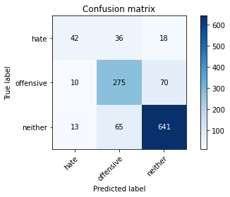

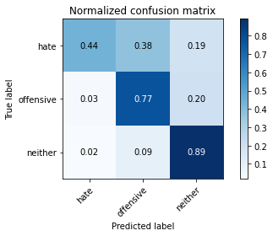

precision recall f1-score support

hate 0.65 0.44 0.52 96

offensive 0.73 0.77 0.75 355

neither 0.88 0.89 0.89 719

accuracy 0.82 1170

macro avg 0.75 0.70 0.72 1170

weighted avg 0.82 0.82 0.82 1170

average eval_loss: 0.6647254831899526, accuracy: 0.8188034188034188

training 7 epoch...

44.21126914024353 seconds used......

7 training finished! average train loss: 0.03072618726296669

evaluating...

Confusion matrix, without normalization

[[ 58 18 20]

[ 36 240 79]

[ 18 38 663]]

Normalized confusion matrix

[[0.60416667 0.1875 0.20833333]

[0.10140845 0.67605634 0.22253521]

[0.02503477 0.05285118 0.92211405]]

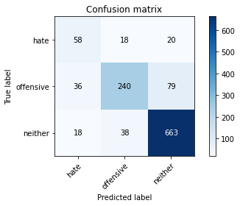

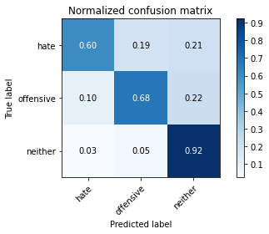

precision recall f1-score support

hate 0.52 0.60 0.56 96

offensive 0.81 0.68 0.74 355

neither 0.87 0.92 0.90 719

accuracy 0.82 1170

macro avg 0.73 0.73 0.73 1170

weighted avg 0.82 0.82 0.82 1170

average eval_loss: 0.8123907216240541, accuracy: 0.8213675213675213

training 8 epoch...

43.91175198554993 seconds used......

8 training finished! average train loss: 0.02719746092826916

evaluating...

Confusion matrix, without normalization

[[ 36 40 20]

[ 6 287 62]

[ 8 89 622]]

Normalized confusion matrix

[[0.375 0.41666667 0.20833333]

[0.01690141 0.8084507 0.17464789]

[0.01112656 0.12378303 0.8650904 ]]

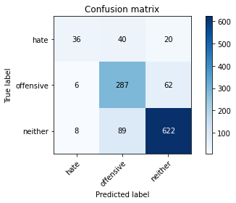

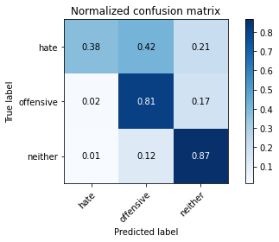

precision recall f1-score support

hate 0.72 0.38 0.49 96

offensive 0.69 0.81 0.74 355

neither 0.88 0.87 0.87 719

accuracy 0.81 1170

macro avg 0.76 0.68 0.70 1170

weighted avg 0.81 0.81 0.80 1170

average eval_loss: 0.85443172284986, accuracy: 0.8076923076923077

training 9 epoch...

43.892000913619995 seconds used......

9 training finished! average train loss: 0.03142508985643856

evaluating...

Confusion matrix, without normalization

[[ 55 31 10]

[ 19 282 54]

[ 25 89 605]]

Normalized confusion matrix

[[0.57291667 0.32291667 0.10416667]

[0.05352113 0.7943662 0.15211268]

[0.03477051 0.12378303 0.84144645]]

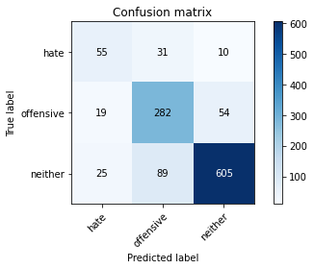

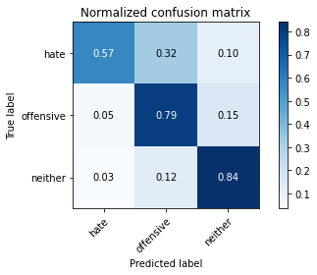

precision recall f1-score support

hate 0.56 0.57 0.56 96

offensive 0.70 0.79 0.75 355

neither 0.90 0.84 0.87 719

accuracy 0.81 1170

macro avg 0.72 0.74 0.73 1170

weighted avg 0.81 0.81 0.81 1170

average eval_loss: 0.7965158440677796, accuracy: 0.8051282051282052

training 10 epoch...

43.86547541618347 seconds used......

10 training finished! average train loss: 0.030476606855194807

evaluating...

Confusion matrix, without normalization

[[ 55 27 14]

[ 16 282 57]

[ 10 70 639]]

Normalized confusion matrix

[[0.57291667 0.28125 0.14583333]

[0.04507042 0.7943662 0.16056338]

[0.01390821 0.09735744 0.88873435]]

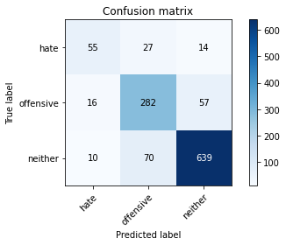

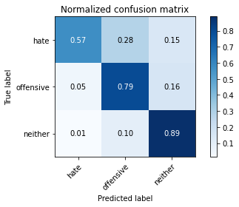

precision recall f1-score support

hate 0.68 0.57 0.62 96

offensive 0.74 0.79 0.77 355

neither 0.90 0.89 0.89 719

accuracy 0.83 1170

macro avg 0.77 0.75 0.76 1170

weighted avg 0.83 0.83 0.83 1170

average eval_loss: 0.7211228563742301, accuracy: 0.8341880341880342

4 run......

training 1 epoch...

43.90907096862793 seconds used......

1 training finished! average train loss: 0.6196642683611976

evaluating...

Confusion matrix, without normalization

[[ 34 40 22]

[ 8 254 93]

[ 7 43 669]]

Normalized confusion matrix

[[0.35416667 0.41666667 0.22916667]

[0.02253521 0.71549296 0.26197183]

[0.00973574 0.05980529 0.93045897]]

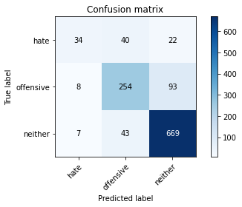

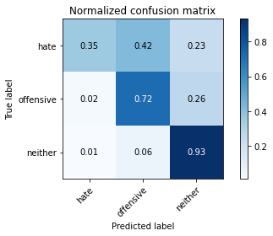

precision recall f1-score support

hate 0.69 0.35 0.47 96

offensive 0.75 0.72 0.73 355

neither 0.85 0.93 0.89 719

accuracy 0.82 1170

macro avg 0.77 0.67 0.70 1170

weighted avg 0.81 0.82 0.81 1170

average eval_loss: 0.4481355196843713, accuracy: 0.8179487179487179

training 2 epoch...

43.99178385734558 seconds used......

2 training finished! average train loss: 0.35072189305200535

evaluating...

Confusion matrix, without normalization

[[ 56 19 21]

[ 36 240 79]

[ 10 41 668]]

Normalized confusion matrix

[[0.58333333 0.19791667 0.21875 ]

[0.10140845 0.67605634 0.22253521]

[0.01390821 0.05702364 0.92906815]]

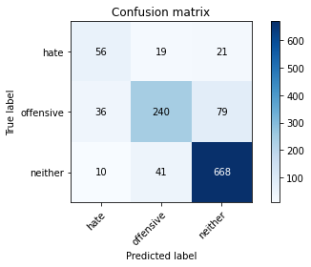

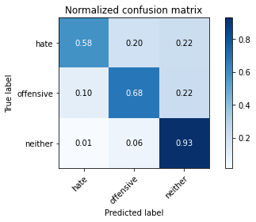

precision recall f1-score support

hate 0.55 0.58 0.57 96

offensive 0.80 0.68 0.73 355

neither 0.87 0.93 0.90 719

accuracy 0.82 1170

macro avg 0.74 0.73 0.73 1170

weighted avg 0.82 0.82 0.82 1170

average eval_loss: 0.4561741840788874, accuracy: 0.8239316239316239

training 3 epoch...

43.985315561294556 seconds used......

3 training finished! average train loss: 0.16450928423044264

evaluating...

Confusion matrix, without normalization

[[ 55 21 20]

[ 25 239 91]

[ 11 31 677]]

Normalized confusion matrix

[[0.57291667 0.21875 0.20833333]

[0.07042254 0.67323944 0.25633803]

[0.01529903 0.04311544 0.94158554]]

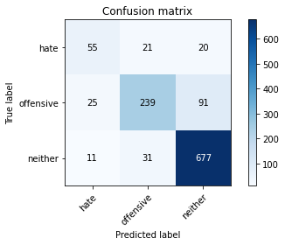

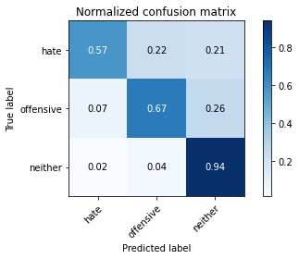

precision recall f1-score support

hate 0.60 0.57 0.59 96

offensive 0.82 0.67 0.74 355

neither 0.86 0.94 0.90 719

accuracy 0.83 1170

macro avg 0.76 0.73 0.74 1170

weighted avg 0.83 0.83 0.82 1170

average eval_loss: 0.587311142534649, accuracy: 0.82991452991453

training 4 epoch...

44.07803726196289 seconds used......

4 training finished! average train loss: 0.0756350877121664

evaluating...

Confusion matrix, without normalization

[[ 61 18 17]

[ 31 244 80]

[ 14 44 661]]

Normalized confusion matrix

[[0.63541667 0.1875 0.17708333]

[0.08732394 0.68732394 0.22535211]

[0.01947149 0.06119611 0.91933241]]

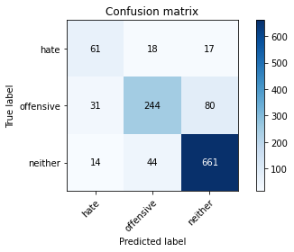

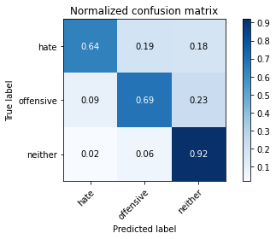

precision recall f1-score support

hate 0.58 0.64 0.60 96

offensive 0.80 0.69 0.74 355

neither 0.87 0.92 0.90 719

accuracy 0.83 1170

macro avg 0.75 0.75 0.75 1170

weighted avg 0.83 0.83 0.82 1170

average eval_loss: 0.6969431094051797, accuracy: 0.8256410256410256

training 5 epoch...

43.93132948875427 seconds used......

5 training finished! average train loss: 0.04577323731580256

evaluating...

Confusion matrix, without normalization

[[ 56 25 15]

[ 27 262 66]

[ 29 60 630]]

Normalized confusion matrix

[[0.58333333 0.26041667 0.15625 ]

[0.07605634 0.73802817 0.18591549]

[0.0403338 0.08344924 0.87621697]]

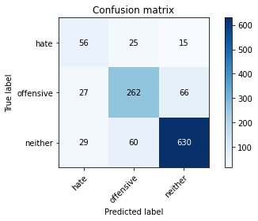

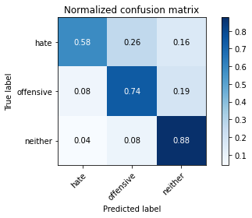

precision recall f1-score support

hate 0.50 0.58 0.54 96

offensive 0.76 0.74 0.75 355

neither 0.89 0.88 0.88 719

accuracy 0.81 1170

macro avg 0.71 0.73 0.72 1170

weighted avg 0.81 0.81 0.81 1170

average eval_loss: 0.7495199472848642, accuracy: 0.8102564102564103

training 6 epoch...

43.97605657577515 seconds used......

6 training finished! average train loss: 0.04037128490720215

evaluating...

Confusion matrix, without normalization

[[ 68 13 15]

[ 47 240 68]

[ 23 44 652]]

Normalized confusion matrix

[[0.70833333 0.13541667 0.15625 ]

[0.13239437 0.67605634 0.1915493 ]

[0.03198887 0.06119611 0.90681502]]

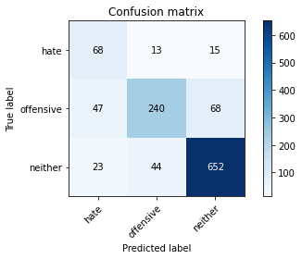

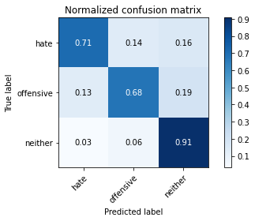

precision recall f1-score support

hate 0.49 0.71 0.58 96

offensive 0.81 0.68 0.74 355

neither 0.89 0.91 0.90 719

accuracy 0.82 1170

macro avg 0.73 0.76 0.74 1170

weighted avg 0.83 0.82 0.82 1170

average eval_loss: 0.8347555971151944, accuracy: 0.8205128205128205

training 7 epoch...

43.85663461685181 seconds used......

7 training finished! average train loss: 0.03170749823766528

evaluating...

Confusion matrix, without normalization

[[ 51 21 24]

[ 21 242 92]

[ 8 33 678]]

Normalized confusion matrix

[[0.53125 0.21875 0.25 ]

[0.05915493 0.68169014 0.25915493]

[0.01112656 0.04589708 0.94297636]]

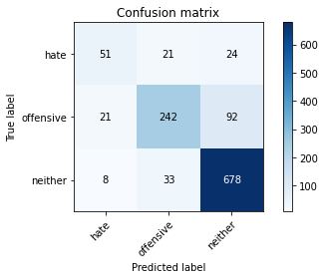

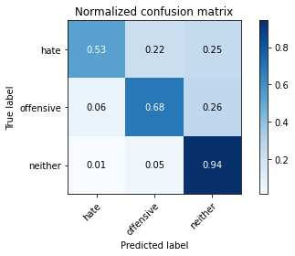

precision recall f1-score support

hate 0.64 0.53 0.58 96

offensive 0.82 0.68 0.74 355

neither 0.85 0.94 0.90 719

accuracy 0.83 1170

macro avg 0.77 0.72 0.74 1170

weighted avg 0.83 0.83 0.82 1170

average eval_loss: 0.7876391931233723, accuracy: 0.82991452991453

training 8 epoch...

44.01719617843628 seconds used......

8 training finished! average train loss: 0.02595881302244006

evaluating...

Confusion matrix, without normalization

[[ 42 44 10]

[ 14 295 46]

[ 12 107 600]]

Normalized confusion matrix

[[0.4375 0.45833333 0.10416667]

[0.03943662 0.83098592 0.12957746]

[0.01668985 0.1488178 0.83449235]]

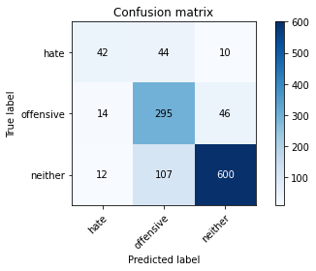

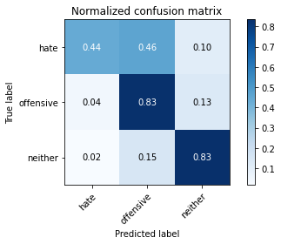

precision recall f1-score support

hate 0.62 0.44 0.51 96

offensive 0.66 0.83 0.74 355

neither 0.91 0.83 0.87 719

accuracy 0.80 1170

macro avg 0.73 0.70 0.71 1170

weighted avg 0.81 0.80 0.80 1170

average eval_loss: 0.8649221393516509, accuracy: 0.8008547008547009

training 9 epoch...

44.01934504508972 seconds used......

9 training finished! average train loss: 0.027744599293646775

evaluating...

Confusion matrix, without normalization

[[ 72 15 9]

[ 50 247 58]

[ 41 59 619]]

Normalized confusion matrix

[[0.75 0.15625 0.09375 ]

[0.14084507 0.69577465 0.16338028]

[0.05702364 0.08205841 0.86091794]]

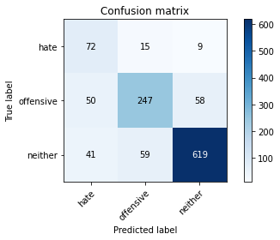

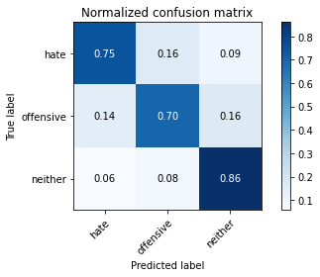

precision recall f1-score support

hate 0.44 0.75 0.56 96

offensive 0.77 0.70 0.73 355

neither 0.90 0.86 0.88 719

accuracy 0.80 1170

macro avg 0.70 0.77 0.72 1170

weighted avg 0.82 0.80 0.81 1170

average eval_loss: 0.9011351591828516, accuracy: 0.8017094017094017

training 10 epoch...

44.167964458465576 seconds used......

10 training finished! average train loss: 0.01986512419298534

evaluating...

Confusion matrix, without normalization

[[ 42 36 18]

[ 20 277 58]

[ 9 70 640]]

Normalized confusion matrix

[[0.4375 0.375 0.1875 ]

[0.05633803 0.78028169 0.16338028]

[0.01251739 0.09735744 0.89012517]]

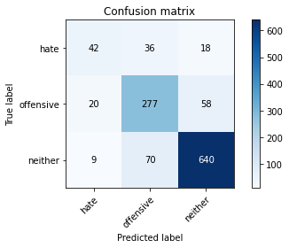

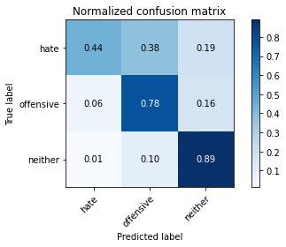

precision recall f1-score support

hate 0.59 0.44 0.50 96

offensive 0.72 0.78 0.75 355

neither 0.89 0.89 0.89 719

accuracy 0.82 1170

macro avg 0.74 0.70 0.72 1170

weighted avg 0.82 0.82 0.82 1170

average eval_loss: 0.8825373315630713, accuracy: 0.8196581196581196

5 run......

training 1 epoch...

44.003344774246216 seconds used......

1 training finished! average train loss: 0.6195317655164971

evaluating...

Confusion matrix, without normalization

[[ 24 41 31]

[ 5 238 112]

[ 1 34 684]]

Normalized confusion matrix

[[0.25 0.42708333 0.32291667]

[0.01408451 0.67042254 0.31549296]

[0.00139082 0.0472879 0.95132128]]

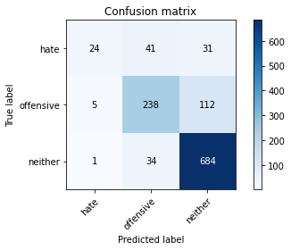

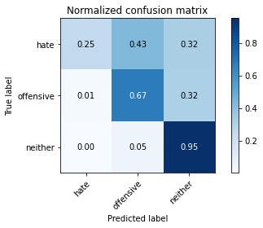

precision recall f1-score support

hate 0.80 0.25 0.38 96

offensive 0.76 0.67 0.71 355

neither 0.83 0.95 0.88 719

accuracy 0.81 1170

macro avg 0.80 0.62 0.66 1170

weighted avg 0.80 0.81 0.79 1170

average eval_loss: 0.466642075423467, accuracy: 0.8085470085470086

training 2 epoch...

44.02840232849121 seconds used......

2 training finished! average train loss: 0.33561025814622897

evaluating...

Confusion matrix, without normalization

[[ 70 18 8]

[ 49 265 41]

[ 48 81 590]]

Normalized confusion matrix

[[0.72916667 0.1875 0.08333333]

[0.13802817 0.74647887 0.11549296]

[0.06675939 0.11265647 0.82058414]]

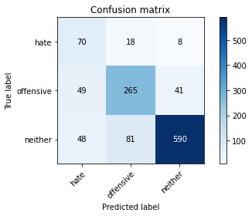

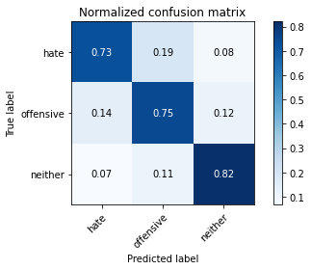

precision recall f1-score support

hate 0.42 0.73 0.53 96

offensive 0.73 0.75 0.74 355

neither 0.92 0.82 0.87 719

accuracy 0.79 1170

macro avg 0.69 0.77 0.71 1170

weighted avg 0.82 0.79 0.80 1170

average eval_loss: 0.5483179701081777, accuracy: 0.7905982905982906

training 3 epoch...

44.20135140419006 seconds used......

3 training finished! average train loss: 0.13939085644948432

evaluating...

Confusion matrix, without normalization

[[ 73 15 8]

[ 39 267 49]

[ 37 79 603]]

Normalized confusion matrix

[[0.76041667 0.15625 0.08333333]

[0.10985915 0.75211268 0.13802817]

[0.05146036 0.10987483 0.83866481]]

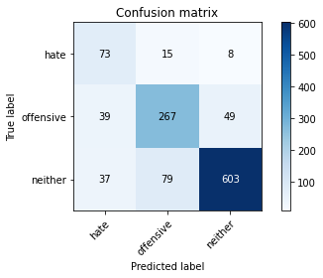

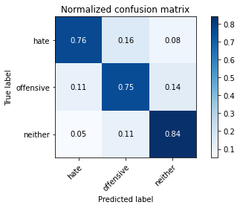

precision recall f1-score support

hate 0.49 0.76 0.60 96

offensive 0.74 0.75 0.75 355

neither 0.91 0.84 0.87 719

accuracy 0.81 1170

macro avg 0.71 0.78 0.74 1170

weighted avg 0.83 0.81 0.81 1170

average eval_loss: 0.5927858681623208, accuracy: 0.805982905982906

training 4 epoch...

43.916181325912476 seconds used......

4 training finished! average train loss: 0.07167049469008373

evaluating...

Confusion matrix, without normalization

[[ 56 16 24]

[ 30 225 100]

[ 9 25 685]]

Normalized confusion matrix

[[0.58333333 0.16666667 0.25 ]

[0.08450704 0.63380282 0.28169014]

[0.01251739 0.03477051 0.9527121 ]]

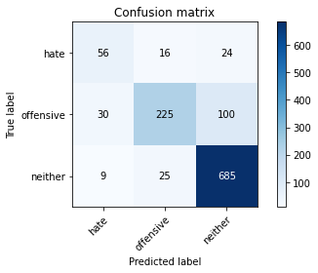

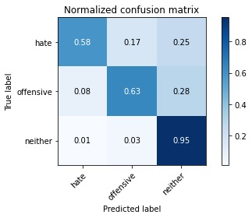

precision recall f1-score support

hate 0.59 0.58 0.59 96

offensive 0.85 0.63 0.72 355

neither 0.85 0.95 0.90 719

accuracy 0.83 1170

macro avg 0.76 0.72 0.74 1170

weighted avg 0.83 0.83 0.82 1170

average eval_loss: 0.6843483038167706, accuracy: 0.8256410256410256

training 5 epoch...

44.13527989387512 seconds used......

5 training finished! average train loss: 0.04671185162778084

evaluating...

Confusion matrix, without normalization

[[ 27 57 12]

[ 8 300 47]

[ 4 115 600]]

Normalized confusion matrix

[[0.28125 0.59375 0.125 ]

[0.02253521 0.84507042 0.13239437]

[0.00556328 0.15994437 0.83449235]]

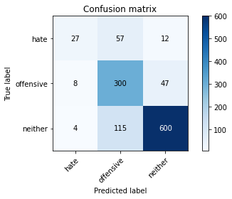

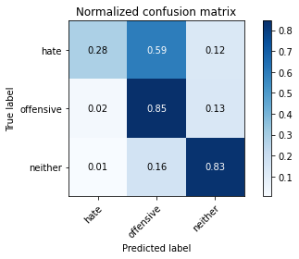

precision recall f1-score support

hate 0.69 0.28 0.40 96

offensive 0.64 0.85 0.73 355

neither 0.91 0.83 0.87 719

accuracy 0.79 1170

macro avg 0.75 0.65 0.67 1170

weighted avg 0.81 0.79 0.79 1170

average eval_loss: 0.8717969875324959, accuracy: 0.7923076923076923

training 6 epoch...

44.053324699401855 seconds used......

6 training finished! average train loss: 0.03763976947102959

evaluating...

Confusion matrix, without normalization

[[ 60 25 11]

[ 23 279 53]

[ 19 75 625]]

Normalized confusion matrix

[[0.625 0.26041667 0.11458333]

[0.06478873 0.78591549 0.14929577]

[0.02642559 0.10431154 0.86926287]]

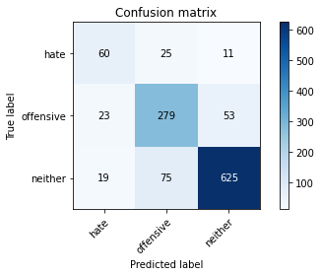

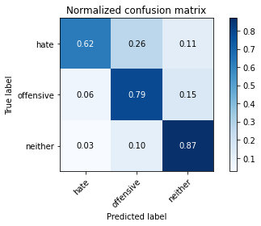

precision recall f1-score support

hate 0.59 0.62 0.61 96

offensive 0.74 0.79 0.76 355

neither 0.91 0.87 0.89 719

accuracy 0.82 1170

macro avg 0.74 0.76 0.75 1170

weighted avg 0.83 0.82 0.83 1170

average eval_loss: 0.7858760671342834, accuracy: 0.8239316239316239

training 7 epoch...

44.195549964904785 seconds used......

7 training finished! average train loss: 0.025576005397082414

evaluating...

Confusion matrix, without normalization

[[ 45 24 27]

[ 16 254 85]

[ 6 33 680]]

Normalized confusion matrix

[[0.46875 0.25 0.28125 ]

[0.04507042 0.71549296 0.23943662]

[0.00834492 0.04589708 0.945758 ]]

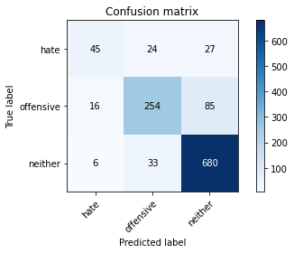

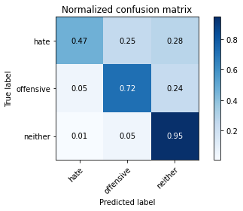

precision recall f1-score support

hate 0.67 0.47 0.55 96

offensive 0.82 0.72 0.76 355

neither 0.86 0.95 0.90 719

accuracy 0.84 1170

macro avg 0.78 0.71 0.74 1170

weighted avg 0.83 0.84 0.83 1170

average eval_loss: 0.7883257937866216, accuracy: 0.8367521367521368

training 8 epoch...

43.89132022857666 seconds used......

8 training finished! average train loss: 0.010634735026449049

evaluating...

Confusion matrix, without normalization

[[ 61 15 20]

[ 31 203 121]

[ 12 13 694]]

Normalized confusion matrix

[[0.63541667 0.15625 0.20833333]

[0.08732394 0.57183099 0.34084507]

[0.01668985 0.01808067 0.96522949]]

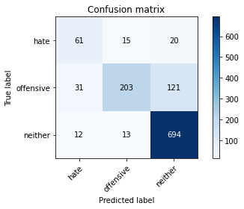

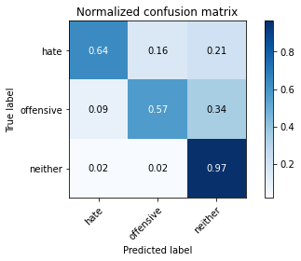

precision recall f1-score support

hate 0.59 0.64 0.61 96

offensive 0.88 0.57 0.69 355

neither 0.83 0.97 0.89 719

accuracy 0.82 1170

macro avg 0.77 0.72 0.73 1170

weighted avg 0.83 0.82 0.81 1170

average eval_loss: 1.0713014483956966, accuracy: 0.8188034188034188

training 9 epoch...

44.09261775016785 seconds used......

9 training finished! average train loss: 0.03043638155512058

evaluating...

Confusion matrix, without normalization

[[ 62 24 10]

[ 27 280 48]

[ 23 89 607]]

Normalized confusion matrix

[[0.64583333 0.25 0.10416667]

[0.07605634 0.78873239 0.13521127]

[0.03198887 0.12378303 0.84422809]]

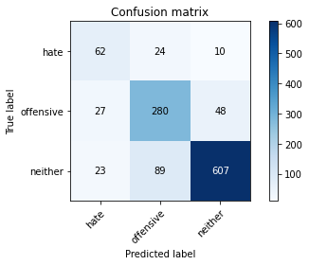

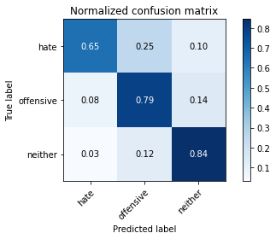

precision recall f1-score support

hate 0.55 0.65 0.60 96

offensive 0.71 0.79 0.75 355

neither 0.91 0.84 0.88 719

accuracy 0.81 1170

macro avg 0.73 0.76 0.74 1170

weighted avg 0.82 0.81 0.82 1170

average eval_loss: 0.9111231268241496, accuracy: 0.8111111111111111

training 10 epoch...

44.13149166107178 seconds used......

10 training finished! average train loss: 0.009399625827816045

evaluating...

Confusion matrix, without normalization

[[ 57 28 11]

[ 21 281 53]

[ 21 86 612]]

Normalized confusion matrix

[[0.59375 0.29166667 0.11458333]

[0.05915493 0.7915493 0.14929577]

[0.02920723 0.11961057 0.8511822 ]]

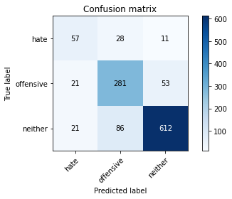

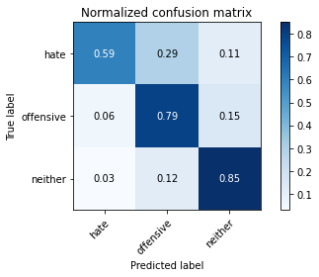

precision recall f1-score support

hate 0.58 0.59 0.58 96

offensive 0.71 0.79 0.75 355

neither 0.91 0.85 0.88 719

accuracy 0.81 1170

macro avg 0.73 0.75 0.74 1170

weighted avg 0.82 0.81 0.81 1170

average eval_loss: 1.0004289031297096, accuracy: 0.811965811965812